JUST AN ORDINARY LAWYER
A play, with songs.
Written and performed by Tayo Aluko
With live piano accompaniment
Directed by Amanda Huxtable, Designed by Emma Williams

“The British Empire was trying desperately to hold on to its colonial possessions by any means … and the foul would often override the fair.”
93 words:
Nigerian Tunji Sowande quietly breaks through multiple barriers to become Britain’s first Black judge in 1978. Also a fine concert singer and keen cricket lover, he muses on international politics and history as they affect the Black world from Africa to the USA and Britain, from the point of view of one who would rather watch sports, and spread love and peace through the medium of song.
Recalling heroic sporting achievements alongside epoch-defining political events, Tayo Aluko follows the multi-award-winning Call Mr. Robeson with another “brilliantly put together history lesson delivered as art.”
47 words:
He is Britain’s first Black judge, a fine singer and keen cricket lover. Finding himself stranded in the Heart of Empire, Nigerian Tunji Sowande muses on Black liberation struggles worldwide. He insists he is no political aficionado, but is content to contribute through his music and songs.
Reviews:
“A fascinating play” (4 stars) The Guardian
“Another triumph … that thrills and touches” (5 Stars) British Theatre Guide
“Immensely enjoyable.” (4 Stars) One4Review
“A superb play” (9/10) Liverpool Sound and Vision
“Every socialist, anti-racist and anti-imperialist will love this” Socialist Worker
“Prepare to be bowled over” Wirral Globe

Click on photos to download print-quality copies:
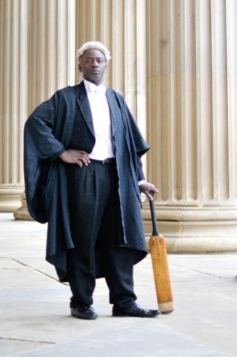
Production stills can be downloaded from this folder
Trailer on youtube: https://youtu.be/BUxQIbLGFpM
Duration: 85 mins (no interval) Age recommendation 14+ No sexual content

